3D-RAD Medical VQA Dataset
Dataset Preparation & Verification Documentation
Sections: Collect · Split · Verification

1. Collect — Dataset Collection
The 3D-RAD dataset (NeurIPS 2025) was obtained from the Hugging Face repository Tang-xiaoxiao/3D-RAD, using the download_full_dataset.py pipeline.

1.1 Source
- Dataset: 3D-RAD — A Comprehensive 3D Radiology Med-VQA Dataset with Multi-Temporal Analysis and Diverse Diagnostic Tasks
- Repository: Tang-xiaoxiao/3D-RAD (Hugging Face Datasets)
- License: Apache 2.0 (QA/dataset repo); source CT scans derived from CT-RATE (CC-BY-NC-SA, non-commercial academic use with attribution)
- Coverage: 6 VQA tasks — Anomaly Detection, Image Observation, Medical Computation, Existence Detection, Static Temporal Diagnosis, Longitudinal Temporal Diagnosis
- Image format: CT scans preprocessed into .npy volumetric arrays; total size ~20.6 GB compressed (~25 GB uncompressed)

1.2 Download Procedure
- Primary method: huggingface_hub.snapshot_download — multi-threaded, auto-resume, hash-verified
- Fallback method: direct resumable HTTP download with byte-range resume and a live progress bar (%, speed, ETA)
- Pre-download check requires ≥25 GB free disk space (≥45–50 GB if the --unzip flag is used)
- Optional --unzip flag auto-extracts Images/test.zip after download

1.3 Result of the Collection Run
Metric | Value
Unique 3D CT volumes found (.npy) | 3,039
Total QA records | 33,910
QA records with verified image match | 33,910 (100%)
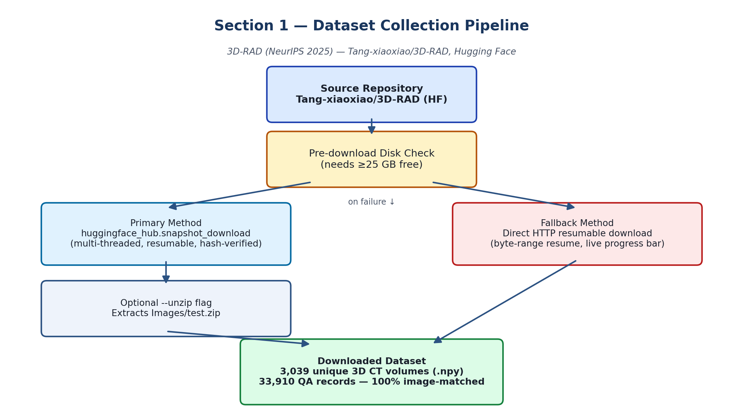
Figure 1 — Dataset collection pipeline: source repository → disk check → download (primary/fallback) → verified local dataset.

2. Split — Patient-Level Dataset Split
Splitting was performed with split_dataset_kaggle.py, using patient-level grouping instead of naive random row splitting.

2.1 Why Patient-Level Splitting
In medical imaging, a single patient can have multiple studies/scans (e.g., a patient's records tagged _a, _b, _d). A naive random split can place different studies of the same patient into both the train and test sets, letting the model memorize patient-specific anatomy and produce inflated, unrealistic accuracy. To prevent this, every record belonging to a given PatientID is assigned to exactly one split.

2.2 Method
- PatientID is derived from the volume filename (first two underscore-separated tokens of NpyName)
- The list of unique patients is shuffled with a fixed random seed (seed = 42)
- Patients are then divided 80% Train / 10% Validation / 10% Test
- Images are symlinked (not copied) into train/images/, val/images/, test/images/ — this avoids exceeding Kaggle's 20 GB working-directory quota

2.3 Actual Split Results
Split | QA Pairs | Unique 3D Scans
Train (80%) | 27,197 | 2,181
Validation (10%) | 3,254 | 255
Test (10%) | 3,459 | 260

2.4 Post-Split Integrity Tests
Test | Result
1. Zero Patient Leakage (Train/Val/Test pairwise) | PASS — 0 overlap in all pairs
2. 3D Image File Existence Check | PASS — 100% of referenced .npy files found
3. 3D Array Voxel Sanity Check | PASS — shape (1, 32, 256, 256), dtype float32, range 0.00–0.99
4. Duplicate (VolumeName, Question) Record Check | Train: 9 duplicates / 27,197; Val: 0; Test: 0
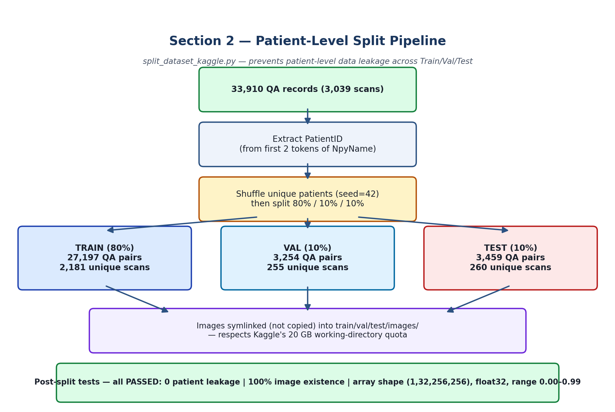
Figure 2 — Patient-level split pipeline: PatientID extraction → seeded shuffle → 80/10/10 split → symlinked images → post-split tests.

3. Verification — Duplicate & Leakage Audit
A dedicated 5-algorithm audit, check_duplicates_kaggle.py, was run against the finished Train/Val/Test split to formally verify data quality and split integrity. Results were saved to duplicate_audit_report.json.

3.1 Algorithm Results
# | Algorithm | Scope | Result
1 | Exact (VolumeName, Question) duplicate check | Intra-split | Train: 9 dup (0.033%), 0 answer conflicts — FLAGGED. Val/Test: 0 — PASSED
2 | Cross-split leakage (patient / volume / VQA-pair) | Inter-split | 0 overlap on all metrics, all split pairs — CLEAN (PASS)
3 | Normalized / near-duplicate text check | Intra-split | Train: 9 (0.033%); Val/Test: 0 — same as Algorithm 1
4 | 3D CT volume bitwise MD5 hash check | Image files | INTERRUPTED before completion (KeyboardInterrupt during hashing) — see 3.2
5 | Global question/answer template redundancy | Whole dataset | 6,027 unique questions, 1,389 unique answers; most frequent question repeats 99 times

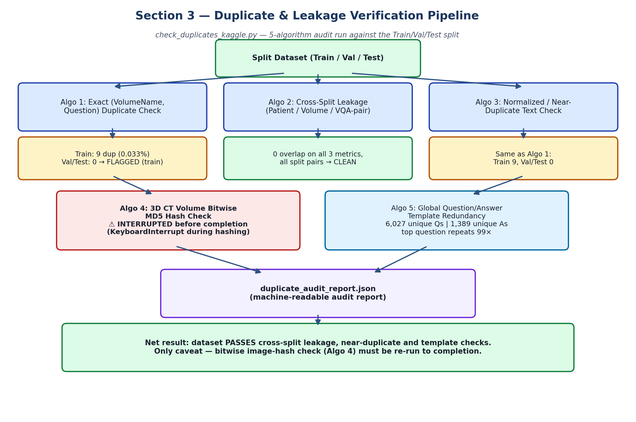
Figure 3 — Five-algorithm verification pipeline and outcomes, ending in the machine-readable audit report.

3.2 Important Accuracy Note — Algorithm 4 Was Not Completed
According to the execution log, Algorithm 4 (the MD5 bitwise hash check) was manually interrupted (KeyboardInterrupt) while hashing the .npy volumes, before any file was hashed. As a result, duplicate_audit_report.json shows all Algorithm 4 values as 0 (total_hashed_volumes: 0, bitwise_identical_scan_clusters: 0, cross-split hash leakage: 0). This reflects an incomplete run, not a verified "zero duplicate images" result, and should not be cited as a passed integrity check in the thesis without re-running it to completion.

3.3 Summary
- Algorithms 1, 2, 3, and 5 completed successfully with the results listed above.
- Algorithm 4 (bitwise image-hash duplication check) must be re-run to completion before being reported as a passed check.
- Overall: the split shows zero patient leakage, zero cross-split VQA/volume overlap, and only a very small (0.033%) intra-train exact-duplicate rate with no label conflicts.

